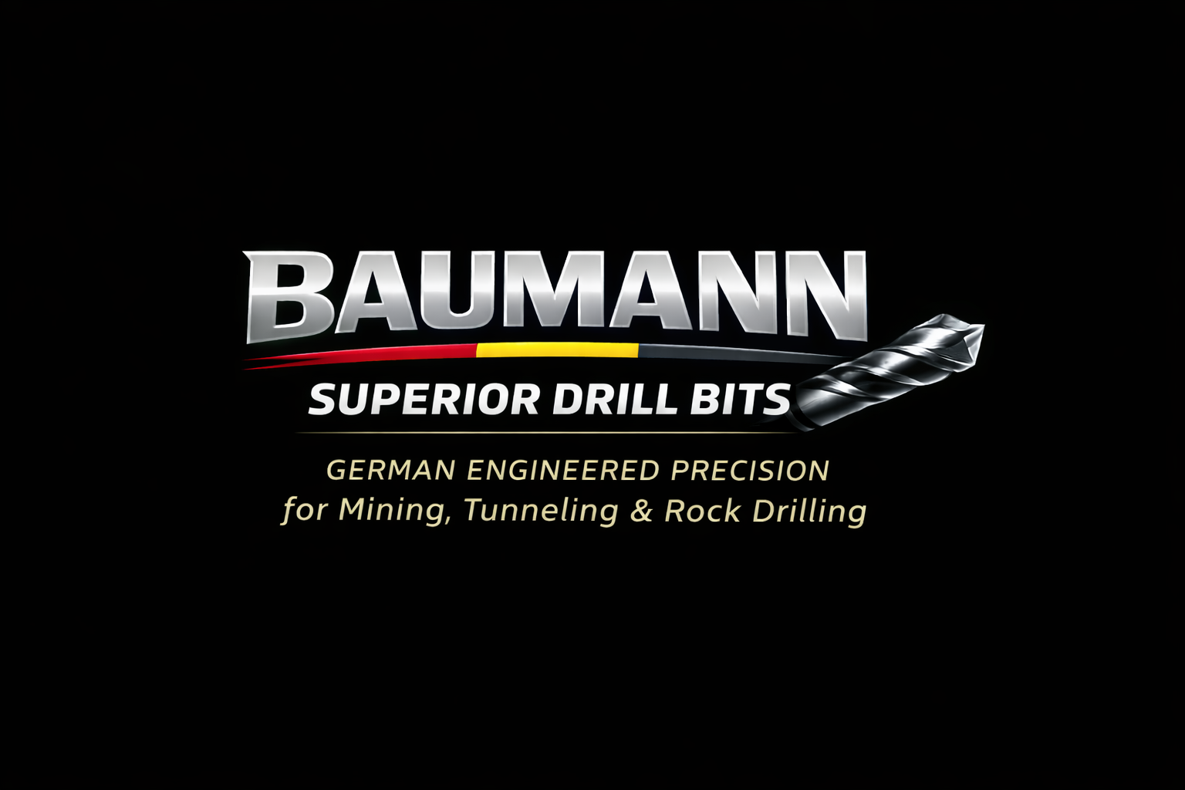
BAU38007D ENTERPRISE SPECIFICATION V10
38 mm Premium Tungsten Carbide Knock-Off Button Bit
Built for Strength. Made to Perform.
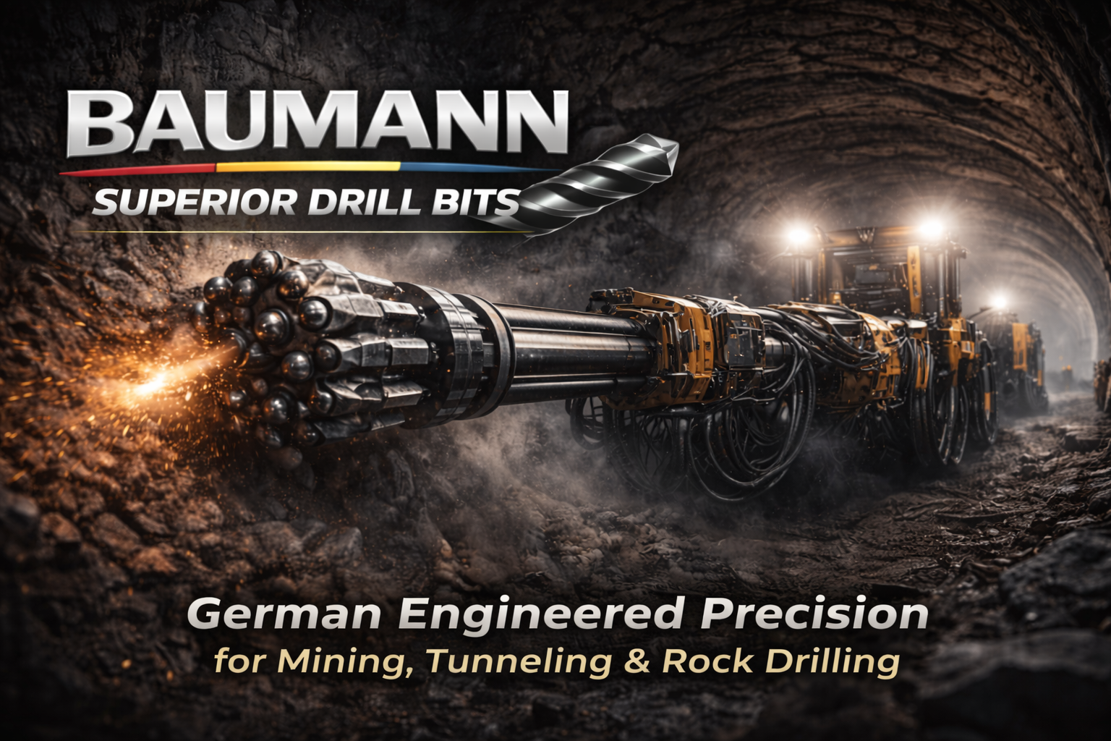
German Engineered Precision for Mining, Quarrying, Tunneling, Construction and Water Well Drilling

Product Overview
━━━━━━
BAUMANN BAU38007D is a 38 mm tungsten carbide knock-off button bit designed for demanding drilling environments. The product combines a heat-treated alloy steel body, premium tungsten carbide buttons, semi-ballistic front geometry and dual flushing holes to support stable penetration, efficient debris removal and reliable performance in abrasive formations.
Features & Benefits
✓ Premium tungsten carbide buttons for superior wear resistance and gauge retention.
✓ Heat-treated alloy steel body for enhanced strength and durability.
✓ Efficient bit geometry for fast penetration and improved drilling productivity.
✓ Suitable for mining, construction, quarrying and water well drilling conditions.
Specifications
Attribute | Value
Diameter | 38 mm
Part number | BAU38007D
Button shape | Domed / semi-ballistic front
Button material | Tungsten Carbide
Body material | Heat-treated alloy steel
Weight (approx.) | 0.45 kg
Gauge angle | 35 degrees
Flushing holes | 2
Application | Mining, Construction, Quarrying, Water Well Drilling
Compatible rods | T38 Thread / 38 mm rods

Actual BAU38007D Product Photos
━━━━━━
Real uploaded BAU38007D product and carton photography included for distributor onboarding, procurement review and product identification.
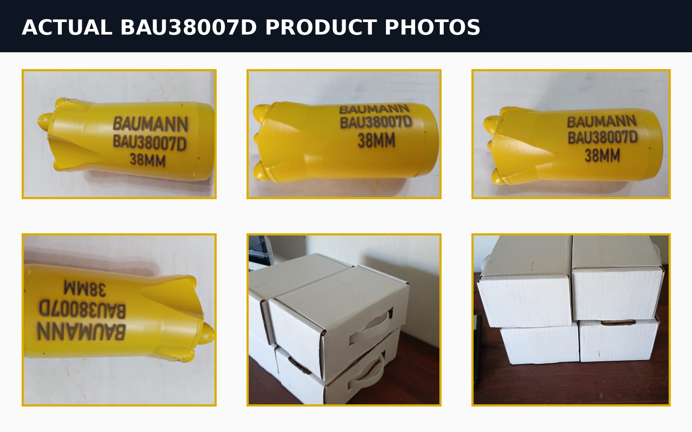

Technical Dimension Drawings
━━━━━━
Reference drawing for product communication. Final CAD tolerances must be confirmed against production drawings before manufacturing or tender submission.
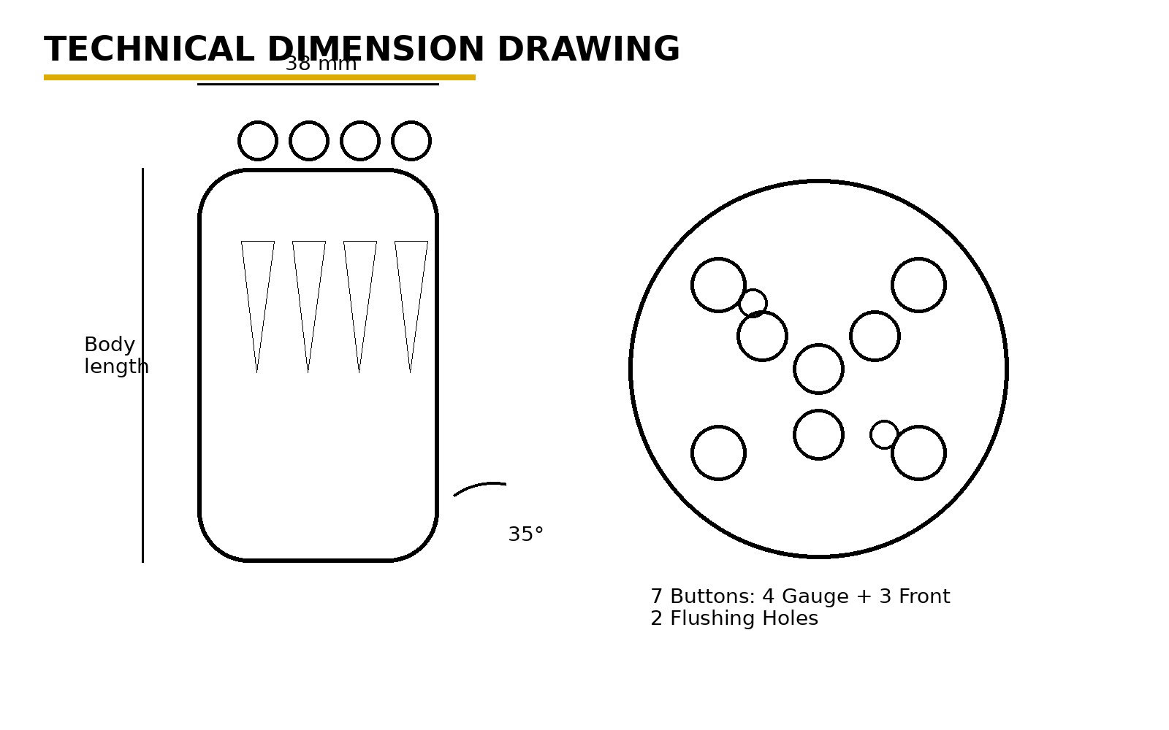

Exploded Bit-Face Diagram
━━━━━━
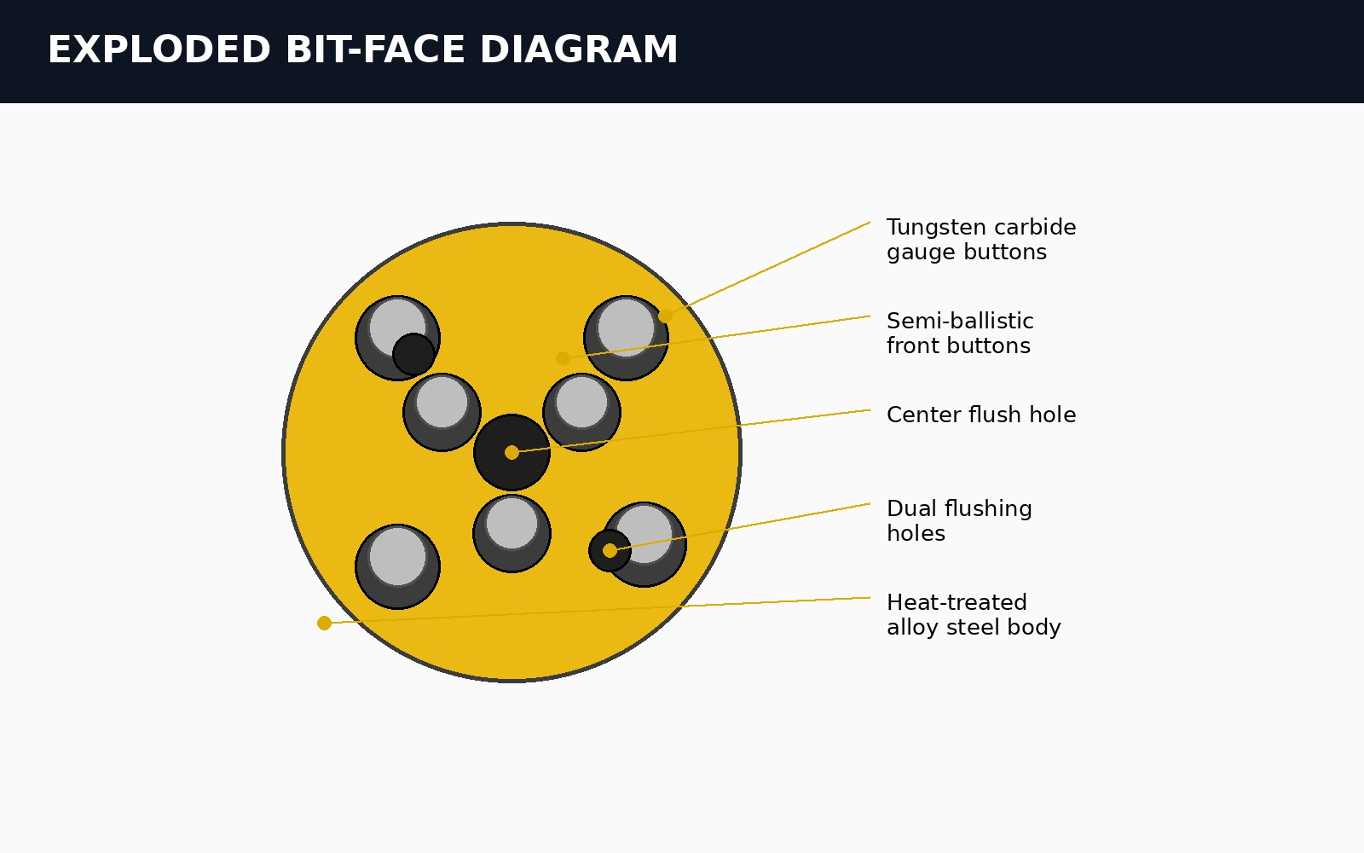
Diagram labels major bit-face elements: tungsten carbide gauge buttons, semi-ballistic front buttons, center flushing hole, dual flushing holes and heat-treated alloy steel body.

Performance & Application Positioning
━━━━━━
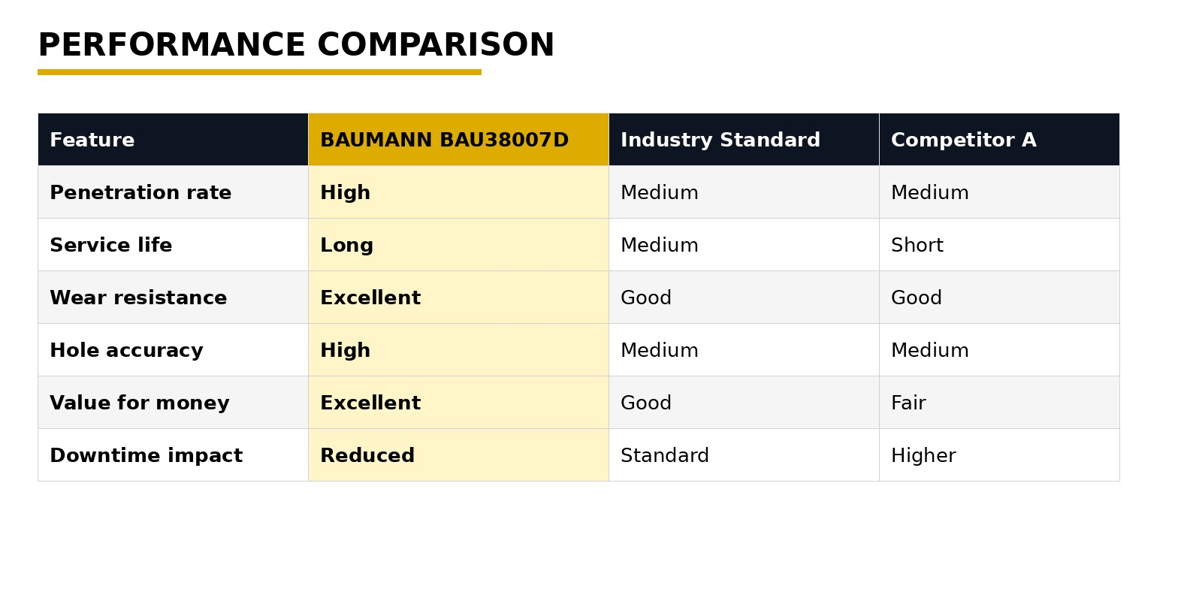
Recommended Rock Formations
✓ Granite, basalt, quartzite, dolomite, hard limestone and iron ore formations.
✓ Recommended for abrasive and high-strength formations in mining, quarrying and tunneling environments.
✓ Suggested target range: 80 - 250 MPa UCS, subject to drilling system, operator control and site conditions.

Manufacturing Quality System
━━━━━━
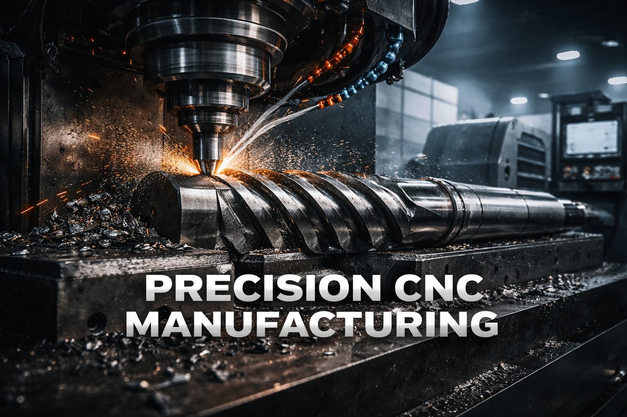
Quality Assurance
✓ Material selection: alloy steel body and tungsten carbide buttons.
✓ Manufacturing process: CNC machining, heat treatment, button fitment and final inspection.
✓ Recommended enterprise quality framework: ISO 9001:2015, ISO 14001 and ISO 45001 alignment.
✓ Traceability fields: product code, size, batch, inspection date and carton quantity.

Packaging Specification
━━━━━━
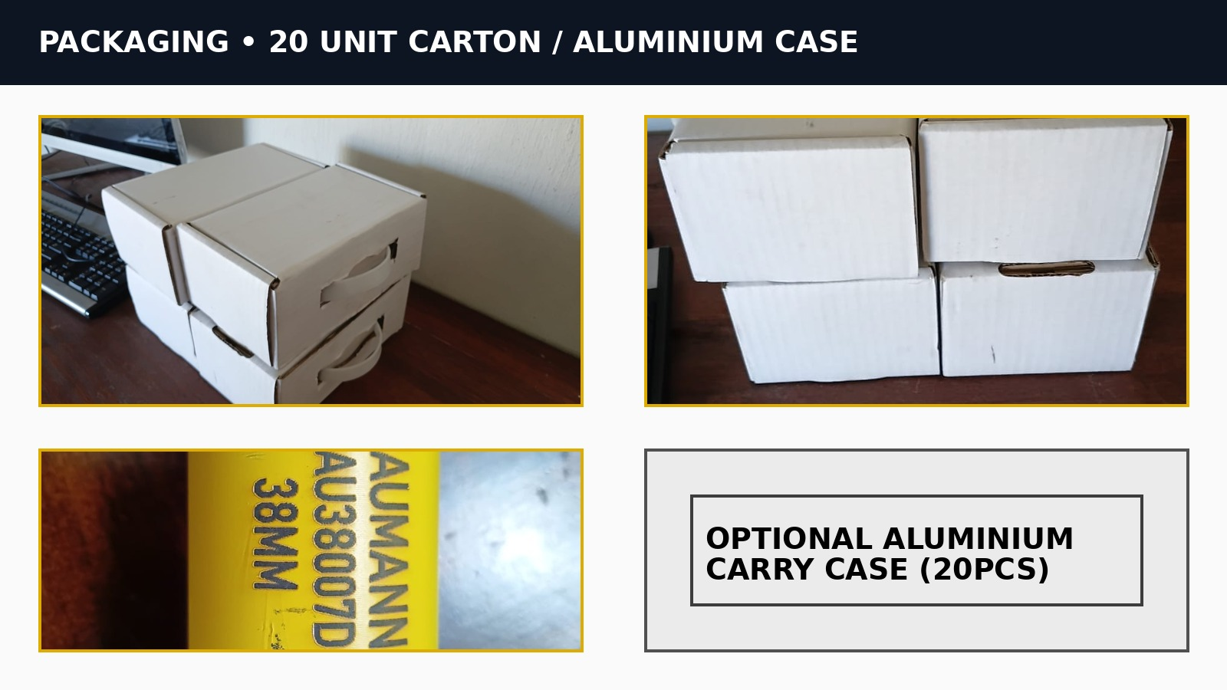
20-Unit Carton / Aluminium Case Option
✓ Standard carton pack quantity: 20 units per master carton.
✓ Industrial box carton for handling and transport.
✓ Optional aluminium carry case for premium distributor presentation or protected site transport.
✓ Product identification: BAU38007D / 38 mm marking.
✓ Packaging supports warehouse storage, distributor handover and site allocation.

Distributor Contact & Commercial Page
━━━━━━
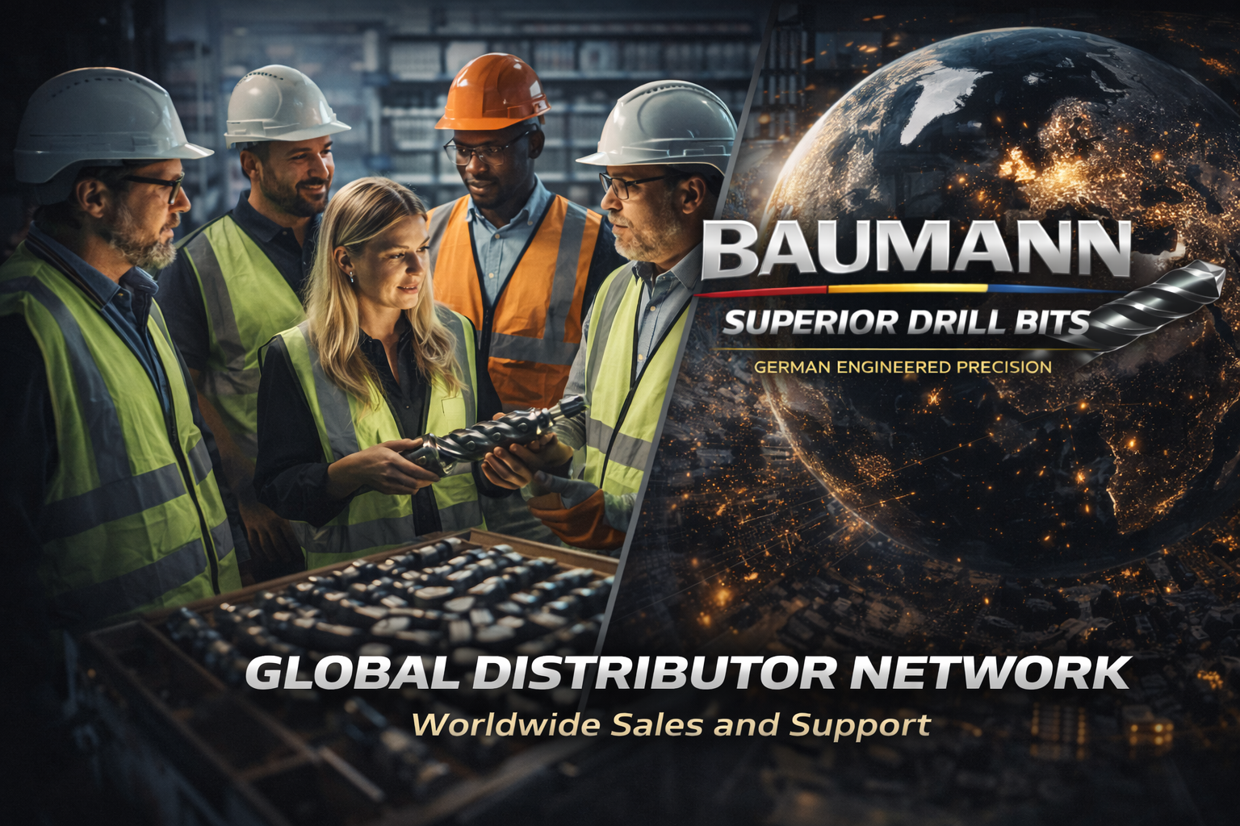
Distributor Positioning
BAUMANN is positioned as a manufacturer-led brand supported by authorized distributors. Public CTA: Find a Distributor.
✓ Find a Distributor
✓ Become a Distributor
✓ Regional technical support and product availability
✓ Product documentation, packaging data and field application support

Procurement-Ready Summary
━━━━━━
Model BAU38007D is specified as a 38 mm knock-off button drill bit with a tungsten carbide cutting system, 7-button configuration, 35-degree gauge angle and dual flushing holes.
Enterprise Positioning Statement
BAUMANN BAU38007D delivers a professional 38 mm drill bit proposition for mining, construction, quarrying and water well drilling applications, supported by actual product photography, technical diagrams, packaging specification and distributor-ready brand material.

